



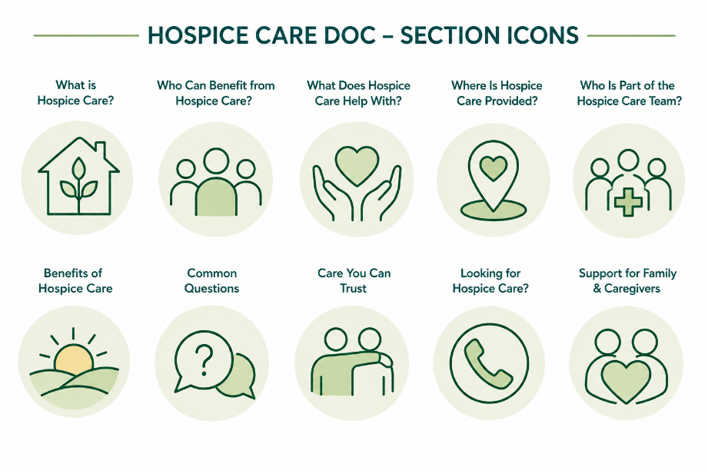
Care You Can Trust
Palliative Care – Patient & Caregiver Fact Sheet

What is Palliative Care?
Palliative care is special type of medical care for people living with a serious illness. It focuses on improving quality of life by helping people manage symptoms, understand their treatment options, and receive care that reflects what matters most to them.
Palliative care can be provided alongside treatments intended to cure an illness and is available at any stage of a serious illness.
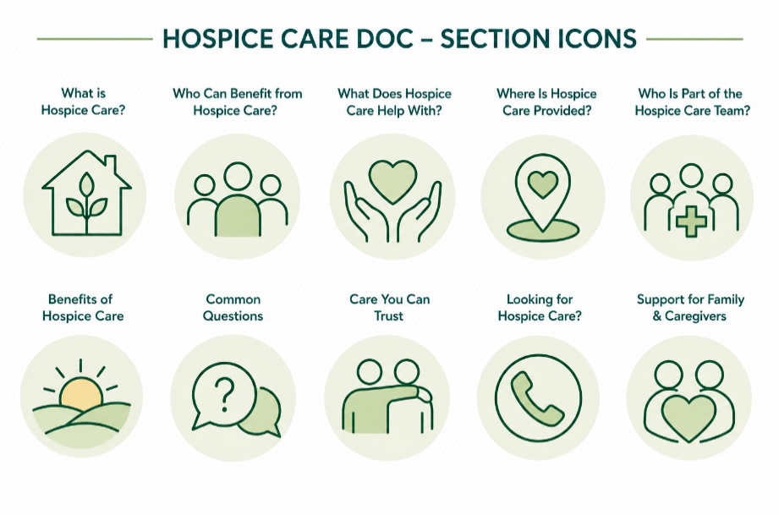
Who Can Benefit from Palliative Care?
Palliative care may be appropriate for people living with a serious illness, including:

- Cancer
- Heart disease
- Lung disease
- Kidney disease
- Dementia
- Parkinson's disease
- Multiple sclerosis
- ALS (Lou Gehrig's disease)
- Other serious or complex medical conditions

You do not have to be nearing the end of life (or have a terminal diagnosis) to start receiving palliative care.
What Does Palliative Care Help With?
Everyone's needs are different. Palliative care can help with:

- Managing pain and other symptoms
- Reducing stress related to illness
- Understanding treatment options
- Coordinating care among healthcare providers
- Planning for future healthcare decisions
- Accessing emotional, social, and spiritual support
- Supporting family members and caregivers
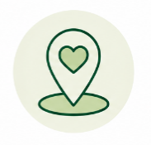
Where Is Palliative Care Provided?
Depending on the program and your needs, palliative care may be provided in:

- Your home
- A hospital
- An outpatient clinic
- A physician's office
- A nursing home or assisted living community

Who Is Part of the Palliative Care Team?
Palliative care is delivered by an interdisciplinary team that works alongside your other healthcare providers.
The team may include:

- Physicians
- Nurse practitioners
- Nurses
- Social workers
- Chaplains or spiritual care providers
- Pharmacists
- Therapists
- Other healthcare professionals

Together, the palliative care team helps make sure care is coordinated and centered around your goals and wishes.
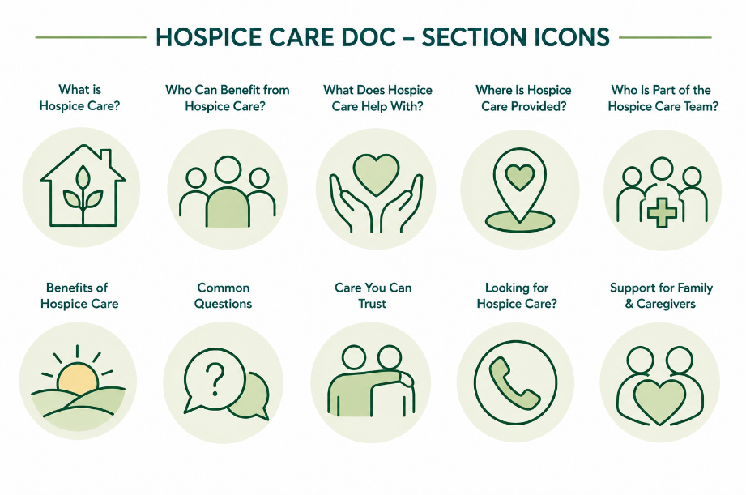
Benefits of Palliative Care
Palliative care can help you:

- Better manage pain and symptoms
- Improve your quality of life
- Feel more confident making healthcare decisions
- Coordinate care across multiple providers
- Receive additional support for yourself and your family

Common Questions
Is palliative care the same as hospice?
No. While both focus on improving quality of life, palliative care is available at any stage of a serious illness and can be provided while you continue receiving treatments intended to cure your illness. Hospice is for people who have shifted from curative treatment.
Can I receive palliative care while seeing my regular doctor?
Yes. Palliative care works alongside your existing healthcare team and complements the care you already receive.
Does receiving palliative care mean my illness is getting worse?
No. Many people begin palliative care early in the course of a serious illness to help manage symptoms, improve communication, and receive additional support.
Is palliative care covered by insurance?
Many palliative care services are covered by Medicare, Medicaid, and private insurance plans. Coverage varies depending on your insurance and the services provided.
Care You Can Trust
No two people experience a serious illness the same way. Palliative care focuses on what matters most to you. It helps make sure your care reflects your goals, your values, and your wishes. If you or someone you love has a serious illness, ask your healthcare provider if palliative care is right for you. The earlier you learn about your options, the more support and choices you'll have.
If you or someone you love is looking for palliative care, we're here to help.
Call 844-GET-NPHI
(844-438-6744)
Or visit www.nphihealth.org/findcare to find a trusted hospice provider near you.

