Palliative Care Sample Social Media Language

Overview
"Care You Can Trust" is a reminder that quality palliative care is built on transparency, accountability, and an unwavering commitment to the people it serves. In a time where trust in healthcare has been tested, this campaign is an opportunity to set the record straight — to show the public what real palliative care looks like, and to celebrate the organizations and care teams who deliver it with integrity every single day.
This past year, hospice fraud has gotten a lot of attention in the media. That coverage has made it more important than ever to get back to basics: to clearly explain what quality hospice and palliative care actually look like, and to reassure the public that trustworthy care is out there.
This document gives NPHI members (and non-members can join!) the language and graphics needed to communicate clear messages throughout the month of November. Members are encouraged to also review the full Messaging Toolkit for additional guidance and context.

Messaging Goals
- Invite public reflection, participation, and storytelling around hospice and palliative care
- Shift the narrative: palliative care can be at any stage of serious illness
- Educate the public about what palliative care really is
- Celebrate care teams and caregivers for their compassion and share uplifting stories about patients
- Use positive and uplifting imagery and plain English that can be understood at a 6th grade reading level
- Build public trust by being honest, clear, and consistent in every message
Sample Social Posts
Sample Language | Accompanying Graphic
Sample Post 1: What Is Palliative Care?  Facebook / Instagram / LinkedIn:  Palliative care is extra help. It treats pain and stress for people who are living with a serious illness. This kind of care can help at any age and at any stage of illness. It focuses on comfort, quality of life, and support for the whole person, not just the illness. It's care you can trust.  #PalliativeCare #CareYouCanTrust  X / BlueSky:  Palliative care is extra help. It treats pain and stress for people with a serious illness, at any age or stage. It's care you can trust.  #Palliative Care #CareYouCanTrust |   Graphic 2
Sample Post 2: Palliative Care Is a Team Effort  Facebook / Instagram / LinkedIn:  Palliative care is a team of specialists working together for you. Doctors, nurses, social workers, and counselors team up to treat pain, ease worries, and help you feel better day to day.  The goal is simple: improve your quality of life.  #PalliativeCare #CareYouCanTrust  X / BlueSky:  Palliative care is a team of specialists working to improve your quality of life.  #PalliativeCare #CareYouCanTrust |   Graphic 3
Sample Post 3: Palliative Care Works Alongside Your Treatment  Facebook / Instagram / LinkedIn:  Palliative care isn't a replacement for your medical treatment — it's an extra layer of support that works right alongside it. You can keep seeing your regular doctors and getting treatment for your illness while a palliative team helps manage pain, worries, and other tough symptoms.  #PalliativeCare #CareYouCanTrust  X / BlueSky:  Palliative care is an extra layer of support that works alongside your regular treatment, not instead of it.  #PalliativeCare #CareYouCanTrust | 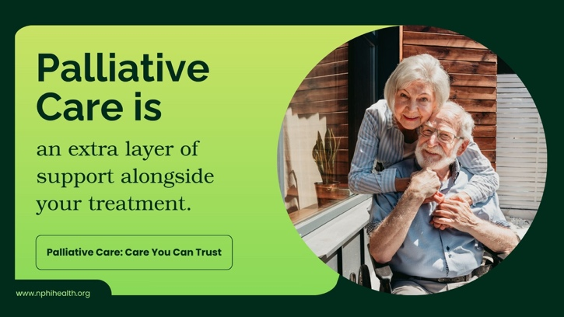  Graphic 4
Sample Post 4: Palliative Care Brings Comfort Back  Facebook / Instagram / LinkedIn:  Palliative care offers help with tough symptoms like pain, an upset stomach, and tiredness. Instead of just managing an illness, the focus turns to how you feel each day — so you can enjoy time with family, get back to hobbies, and simply live more comfortably.  #PalliativeCare #CareYouCanTrust  X / BlueSky:  Palliative care means expert relief from tough symptoms, so you can live more comfortably.  #PalliativeCare #CareYouCanTrust |   Graphic 5
Sample Post 5: Palliative Care Fits Your Life  Facebook / Instagram / LinkedIn:  Palliative care is built around you, not the other way around. Your care team listens to what matters most to you and shapes a plan that fits your goals, your family, and the life you want to keep living.  #PalliativeCare #CareYouCanTrust  X / BlueSky:  Palliative care fits around your life and your goals, not the other way around.  #PalliativeCare #CareYouCanTrust | 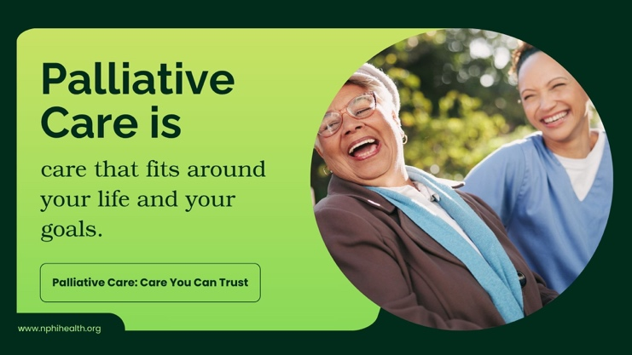  Graphic 6
Sample Post 6: Palliative Care Handles the Details  Facebook / Instagram / LinkedIn:  Palliative care goes beyond doctor visits. It also connects you with the medications, equipment, and supplies you need for daily care — things like hospital beds, walkers, or wound care items. One less thing for you and your family to figure out on your own.  #PalliativeCare #CareYouCanTrust  X / BlueSky:  Palliative care helps with medications, equipment, and supplies related to your care.  #PalliativeCare #CareYouCanTrust | 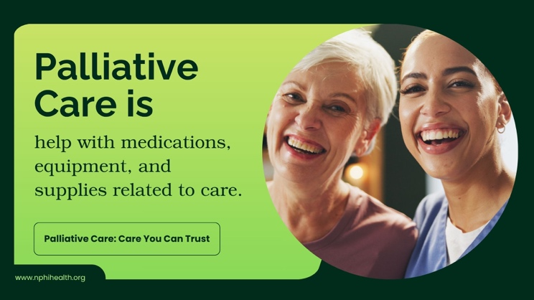  Graphic 7
Sample Post 7: Palliative Care Meets You Where You Are  Facebook / Instagram / LinkedIn:  Palliative care can come to you, wherever you call home. That might be your house, an apartment, or a care facility. You don't have to travel back and forth for appointments — your care team fits into your life, not the other way around.  #PalliativeCare #CareYouCanTrust  X / BlueSky:  Palliative care meets you wherever you call home — house, apartment, or care facility.  #PalliativeCare #CareYouCanTrust | 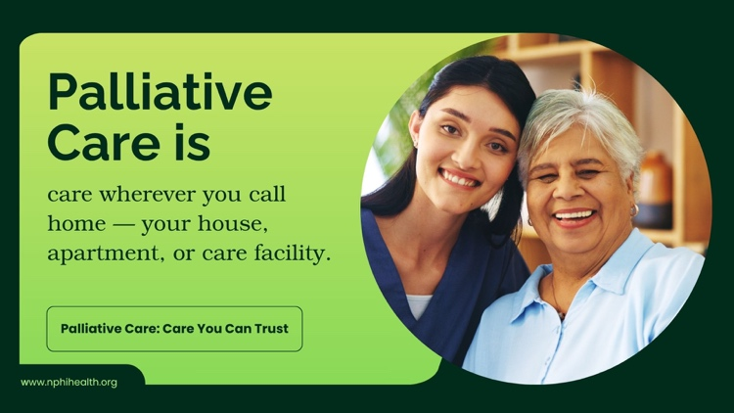  Graphic 8
Sample Post 8: Palliative Care Is for Every Age and Stage  Facebook / Instagram / LinkedIn:  Palliative care isn't limited by age or diagnosis. Children, adults, and older adults living with a serious illness can all benefit — whether it's early on or later in the illness. It's about getting support as soon as it's needed, not waiting until things get harder.  #PalliativeCare #CareYouCanTrust  X / BlueSky:  Palliative care is for anyone with a serious illness, at any age, at any stage of diagnosis.  #PalliativeCare #CareYouCanTrust |   Graphic 9
Sample Post 9: You Can Ask for Palliative Care  Facebook / Instagram / LinkedIn:  You don't have to wait for a doctor to bring it up. Palliative care is something you can ask for yourself, for a loved one you're caring for, or on behalf of a patient. If you think it could help, speak up — you don't need a referral to start the conversation.  #PalliativeCare #CareYouCanTrust  X / BlueSky:  Palliative care is something you can ask for. You don't have to wait to be referred.  #PalliativeCare #CareYouCanTrust | 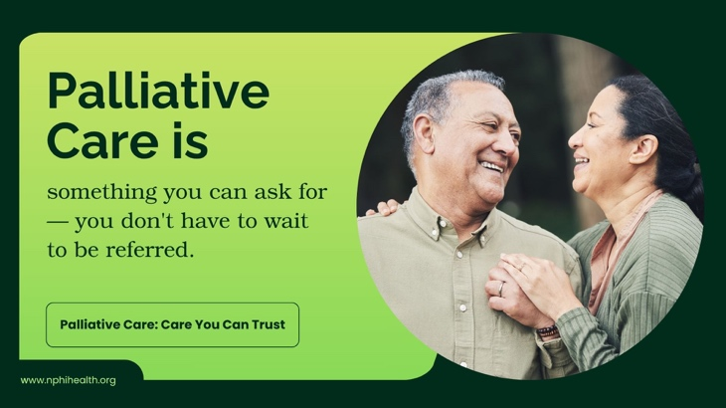  Graphic 10
Sample Post 10: Palliative Care Cares for the Whole Person  Facebook / Instagram / LinkedIn:  Did you know that palliative care goes beyond medicine? It’s emotional support, spiritual care, and practical help for the everyday challenges that come with a serious illness.  #PalliativeCare #CareYouCanTrust  X / BlueSky:  Palliative care is much more than medicine — it's emotional, spiritual, and full support for the whole person.  #PalliativeCare #CareYouCanTrust |   Graphic 11

