


Care You Can Trust
Hospice Care – Patient & Caregiver Fact Sheet

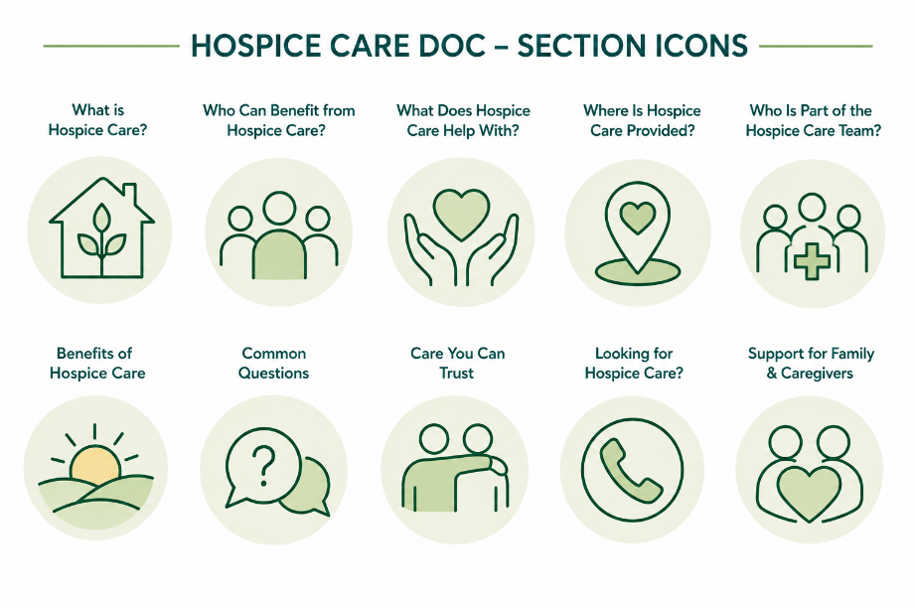
What is Hospice Care?
Hospice care is a special kind of healthcare for people living with a serious illness who are nearing the end of life. It focuses on comfort and quality of life rather than trying to cure an illness.
Hospice helps people live as comfortably as possible by managing pain and symptoms and providing emotional, spiritual, and practical support for both patients and their families.
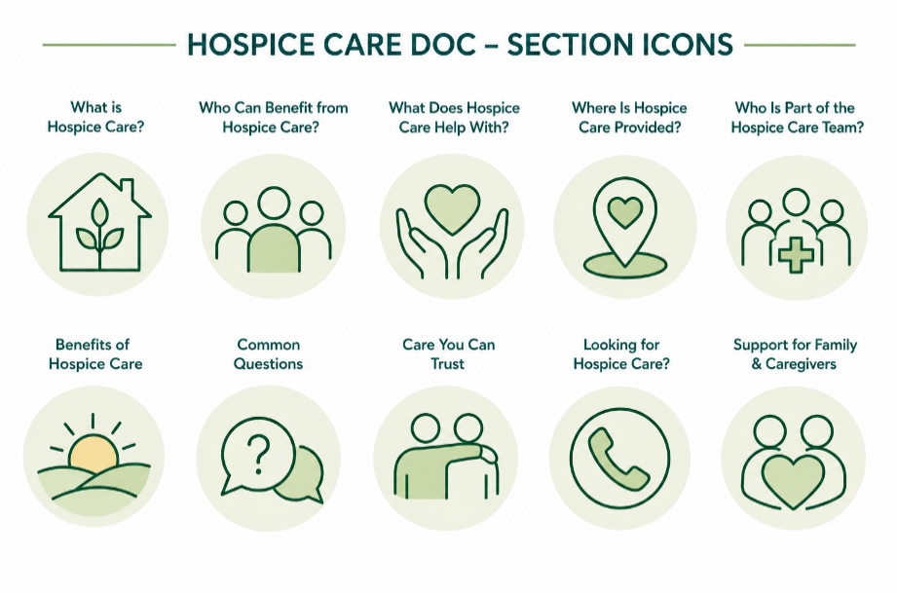
Most people receive hospice care wherever they call home.
Who Can Benefit from Hospice Care?
Hospice may be appropriate for people with a serious illness when treatment is no longer helping or they choose to focus on comfort and quality of life. People receiving hospice care may have illnesses such as:

- Cancer
- Heart disease
- Lung disease
- Kidney disease
- Dementia
- Parkinson's disease
- Multiple sclerosis
- ALS (Lou Gehrig's disease)
- Other serious or life-limiting illnesses

A healthcare provider can help determine whether hospice is the right choice.
What Does Hospice Care Help With?
Everyone's needs are different. Hospice care can help with:

  - Managing pain and other symptoms
  - Providing nursing care and medical support
  - Helping patients remain comfortable at home
  - Offering emotional and spiritual support
  - Helping patients enjoy their final wishes
  - Supporting family members and caregivers
  - Providing medications, medical equipment, and supplies related to the hospice diagnosis.
  - Helping families prepare for what to expect.
  - Providing grief and bereavement support for loved ones.
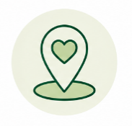
Where Is Hospice Care Provided?
Depending on the program and your needs, hospice care may be provided in:

- Your home
- A hospice inpatient unit (if extra care is needed)
- A hospital (when needed)
- A nursing home or assisted living community
- Anywhere the patient calls home
Who Is Part of the Hospice Care Team?
Hospice care is provided by an “interdisciplinary team” that works together to meet each person's physical, emotional, and spiritual needs.
The team may include:

- Physicians
- Nurse practitioners
- Nurses
- Social workers
- Hospice aides
- Volunteers
- Chaplains or spiritual care providers
- Pharmacists
- Therapists
- Bereavement counselors
- Other healthcare professionals

Together, they support both the patient and the people who care about them.
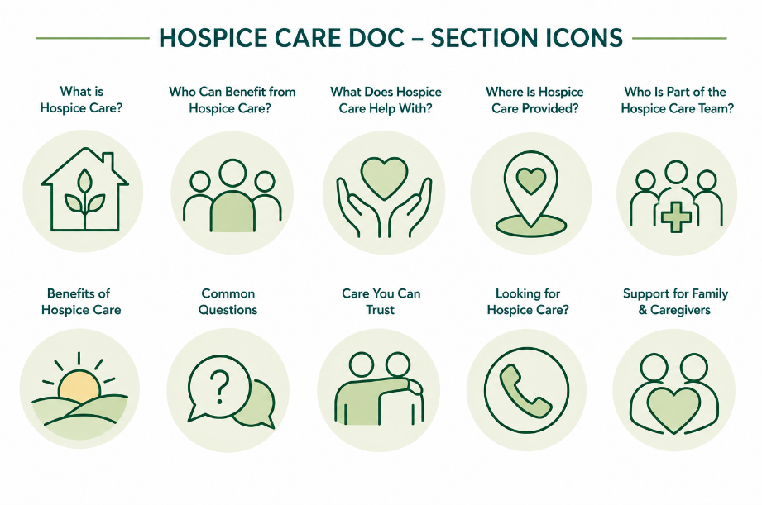
Benefits of Hospice Care
Hospice care can help you:

  - Better manage pain and symptoms
  - Remain comfortable wherever you live
  - Receive care that respects your wishes
  - Reduce unnecessary trips to the hospital
  - Receive emotional and spiritual support
  - Give family caregivers guidance and support
  - Improve quality of life for both patients and families
Common Questions

Is hospice only for the last few days of life?
No. Many people receive hospice care for weeks or even months. Starting hospice earlier often allows patients and families to receive more support and better symptom management.
Does choosing hospice mean giving up?
No. Hospice does not mean giving up. It means focusing on comfort, quality of life, and spending meaningful time with the people who matter most.

Can I stay in my own home?
In many cases, yes. Most hospice care is provided in the patient's home or wherever they live.
Does hospice support family caregivers?
Yes. Hospice cares for both the patient and the family. The hospice team provides education, emotional support, respite resources, and grief support.
Is hospice covered by insurance?
Hospice is covered by Medicare for eligible patients. Many Medicaid programs and private insurance plans also cover hospice services.

Care You Can Trust
Choosing hospice is a personal decision. Hospice focuses on helping people live each day as comfortably and meaningfully as possible while providing compassionate support for the whole family.
If you or someone you love is living with a serious illness and treatment is no longer meeting your goals, talk with your healthcare provider about whether hospice care may be right for you. Learning about hospice early gives you more time to receive the care and support you deserve.
Looking for Hospice Care?
If you or someone you love is looking for hospice care, we're here to help.

Call 844-GET-NPHI
(844-438-6744)
Or visit www.nphihealth.org/findcare to find a trusted hospice provider near you.



