Hospice Sample Social Media Language

Overview
"Care You Can Trust" is a reminder that quality hospice care is built on transparency, accountability, and a commitment to the people it serves. In a time where trust in hospice care has been tested, this campaign is an opportunity to set the record straight — to show the public what quality hospice care looks like, and to celebrate the organizations and care teams who deliver it with integrity every single day.
This past year, hospice fraud has received a lot of attention in the media. That coverage has made it more important than ever to get back to basics: to clearly explain what quality hospice and palliative care actually look like, and to reassure the public that trustworthy care is out there.
This document gives NPHI members (and non-members can join!) the language and graphics needed to communicate clear messages throughout the month of November. Members are encouraged to also review the full Messaging Toolkit on our Campaign Hub for additional guidance and context.

Messaging Goals
- Invite public reflection, participation, and storytelling around hospice and palliative care
- Shift the narrative: hospice is about living well, not just dying
- Educate the public about what hospice care looks like
- Celebrate care teams and caregivers for their compassion and share uplifting stories about patients
- Use positive and uplifting imagery and plain English that can be understood at a 6th grade reading level
- Build public trust by being honest, clear, and consistent in every message

Sample Social Posts
We recommend adjusting some of this language to speak directly to the caregiver/family members.
Sample Language | Accompanying Graphic
Sample Post 1: Hospice Comes to You  Facebook / Instagram / LinkedIn:  Hospice care comes to wherever you call home, whether that's your house, an apartment, or a care facility. This means families can stay together during a hard time, without added trips back and forth to a hospital or clinic.  #HospiceMonth #HospiceAwareness #CareYouCanTrust  X / BlueSky:  Hospice comes to wherever you call home, so families can stay together.  #HospiceMonth #CareYouCanTrust | 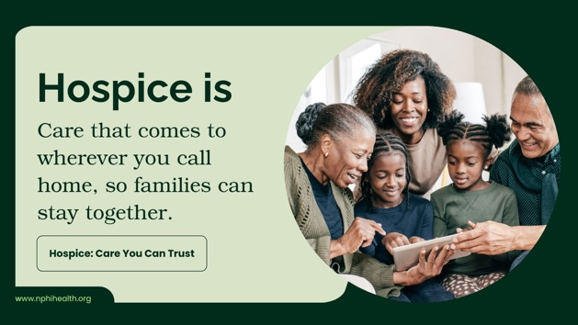  Graphic 2
Title: Hospice Helps Make Memories Possible  Facebook / Instagram / LinkedIn:  Good hospice care isn't just about managing symptoms.  By easing pain and stress, hospice helps patients feel well enough to enjoy a walk in the garden, a favorite song, or time with family, making one more good memory possible.  #CareYouCanTrust #Hospice  X / BlueSky:  Hospice is about making one more memory possible.  #CareYouCanTrust #Hospice |   Graphic 3
Title: Hospice Asks What Matters to You  Facebook / Instagram / LinkedIn:  Every hospice plan starts with one important question: "What matters to you?" Your care team listens to your goals and wishes and builds a plan around them, so your care reflects what's truly important to you and your family.  #CareYouCanTrust #Hospice  X / BlueSky:  Hospice starts by asking, "What matters to you?" Your care team listens and builds a plan around your goals and wishes.  #CareYouCanTrust #Hospice | Graphic 4
Title: Hospice Helps Create Lasting Memories  Facebook / Instagram / LinkedIn:  Hospice care makes room for what matters most: time together. Hospice frees patients and families to focus on each other, creating moments they'll never forget, whether that's a birthday, a visit from grandkids, or just a normal afternoon.  #CareYouCanTrust #Hospice  X / BlueSky:  Hospice helps families create moments and memories they'll never forget.  #CareYouCanTrust #Hospice | 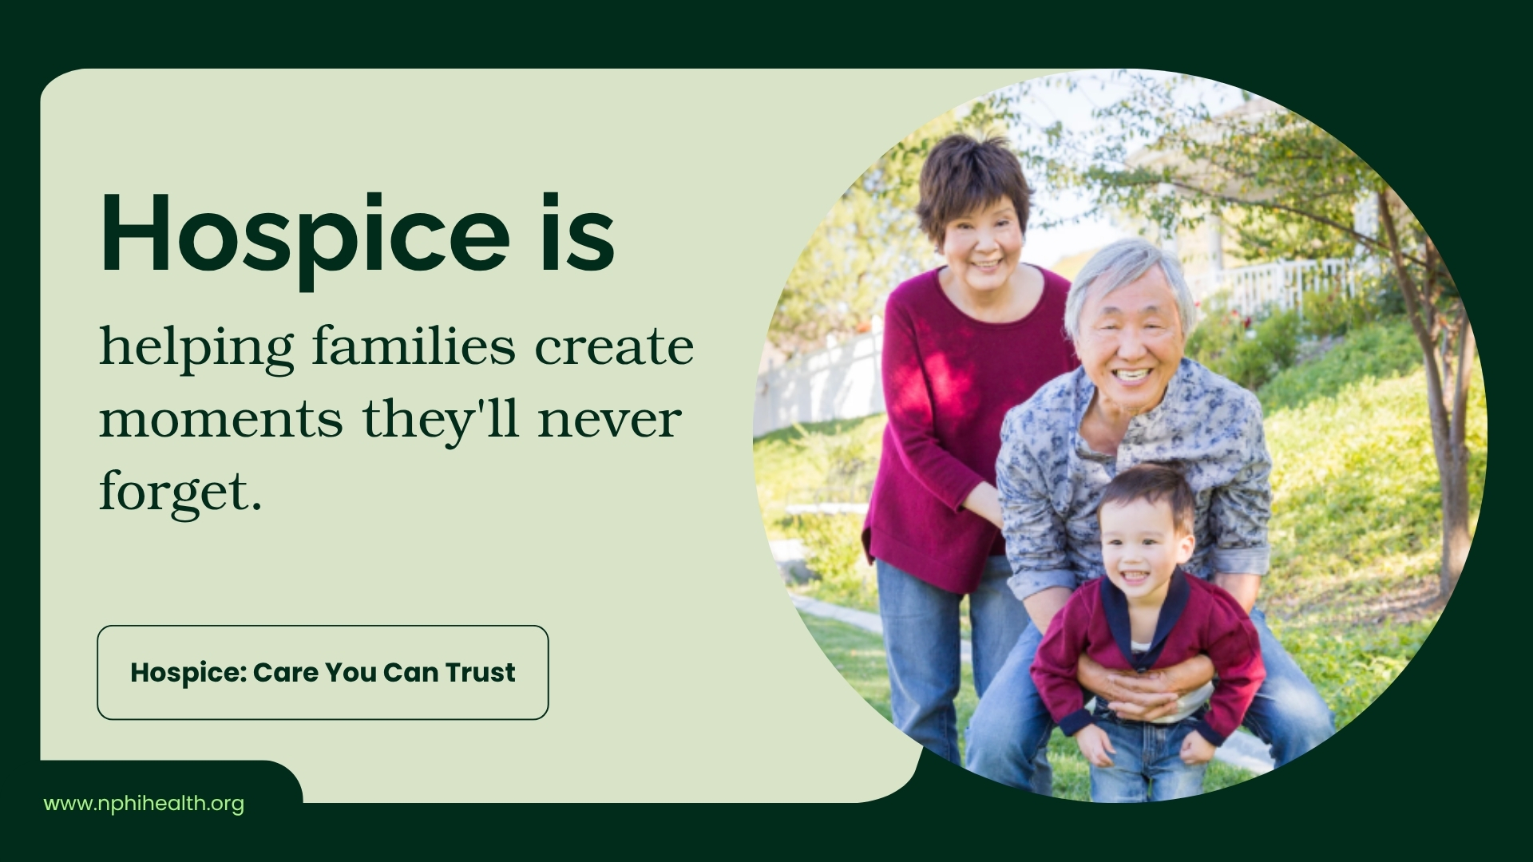  Graphic 5
Title: Hospice Finds Joy in Difficult Days  Facebook / Instagram / LinkedIn:  Even on the hardest days, hospice care makes room for laughter, connection, and small moments of joy. Care teams get to know patients as people, so even a shared laugh or a quiet conversation can bring real comfort.  #CareYouCanTrust #Hospice  X / BlueSky:  Hospice is about finding joy, even on difficult days.  #CareYouCanTrust #Hospice | Graphic 6
Title: Hospice Makes Room for One Last Dance  Facebook / Instagram / LinkedIn:  Hospice care makes the moments that people remember most. It's about helping people feel well enough to hold onto joy and connection, for as long as possible.  #CareYouCanTrust #Hospice  X / BlueSky:  Hospice care makes moments that people remember most... like one last dance.  #CareYouCanTrust #Hospice | 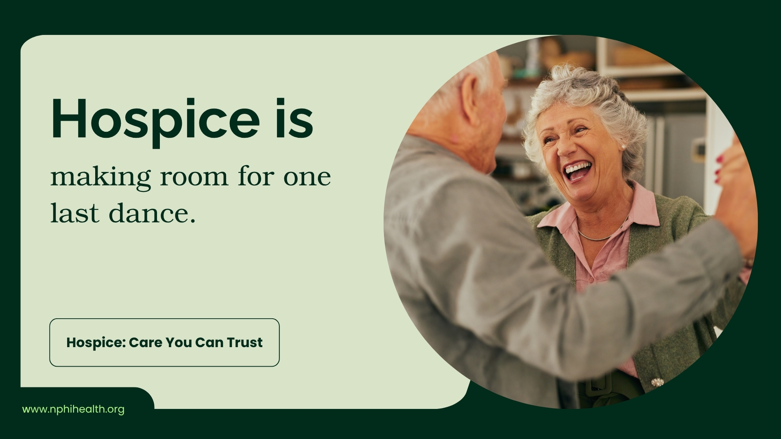  Graphic 7
Title: Hospice Helps Someone Hear Their Favorite Song Again  Facebook / Instagram / LinkedIn:  Music can bring comfort in ways words can't. Many hospice teams use music therapy, helping patients hear a favorite song, share it with loved ones, and feel a moment of peace and connection.  #CareYouCanTrust #Hospice  X / BlueSky:  Hospice is helping someone hear their favorite song one more time, through music therapy that brings comfort and connection.  #CareYouCanTrust #Hospice | 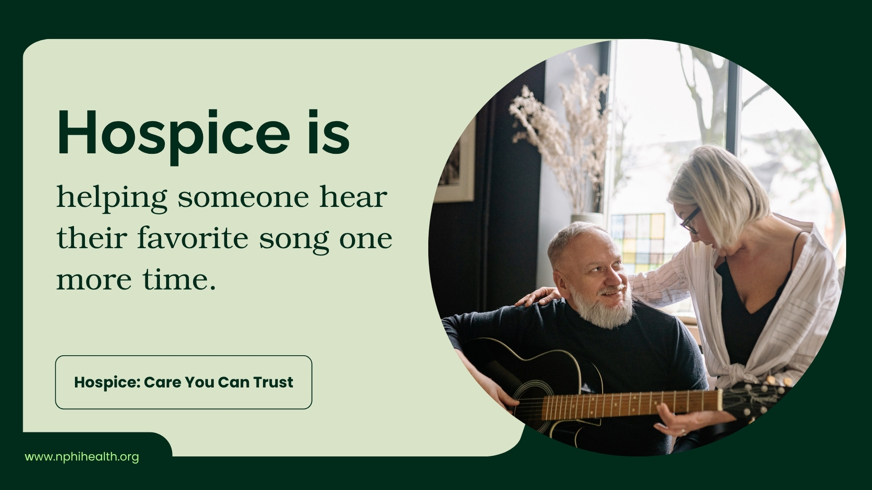 Graphic 8
Title: Hospice Supports the Whole Family  Facebook / Instagram / LinkedIn:  Hospice isn't just care for the patient — it's support for the whole family. From managing illness to offering emotional and practical help, a hospice team helps your family too, so no one has to go through it alone.  #CareYouCanTrust #Hospice  X / BlueSky:  Hospice is support for your whole family, every step of the way.  #CareYouCanTrust #Hospice | 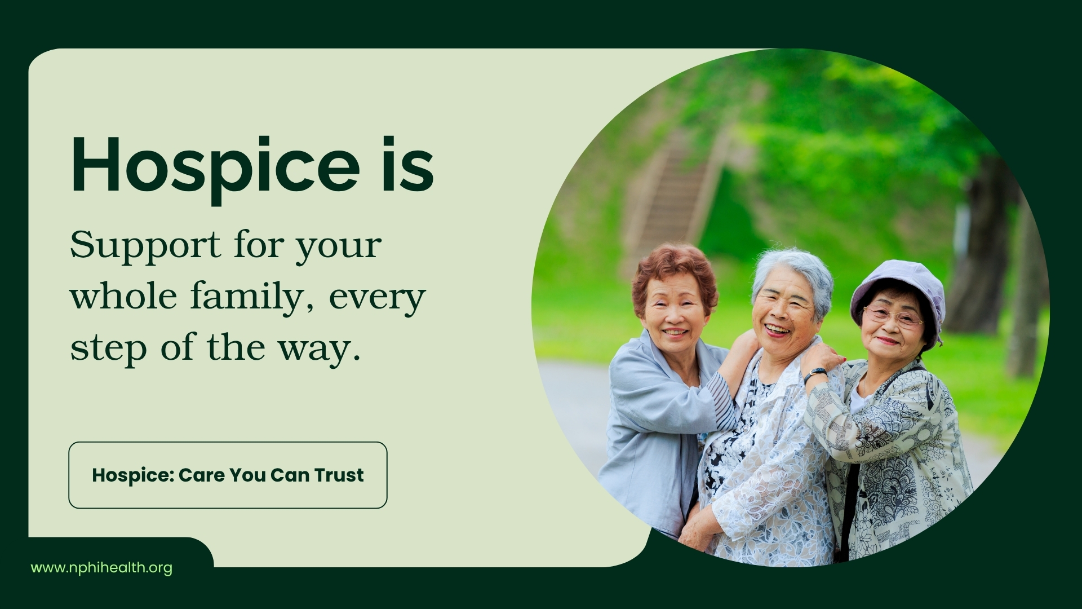  Graphic 9
Title: Hospice Is Always a Phone Call Away  Facebook / Instagram / LinkedIn:  Hospice support doesn't stop at night. A member of your care team is just a phone call away, day or night, whenever you have a question or a concern. You're never left waiting until morning for help.  #CareYouCanTrust #Hospice  X / BlueSky:  Hospice care gives you someone you can call anytime, day or night, with questions or concerns.  #CareYouCanTrust #Hospice | 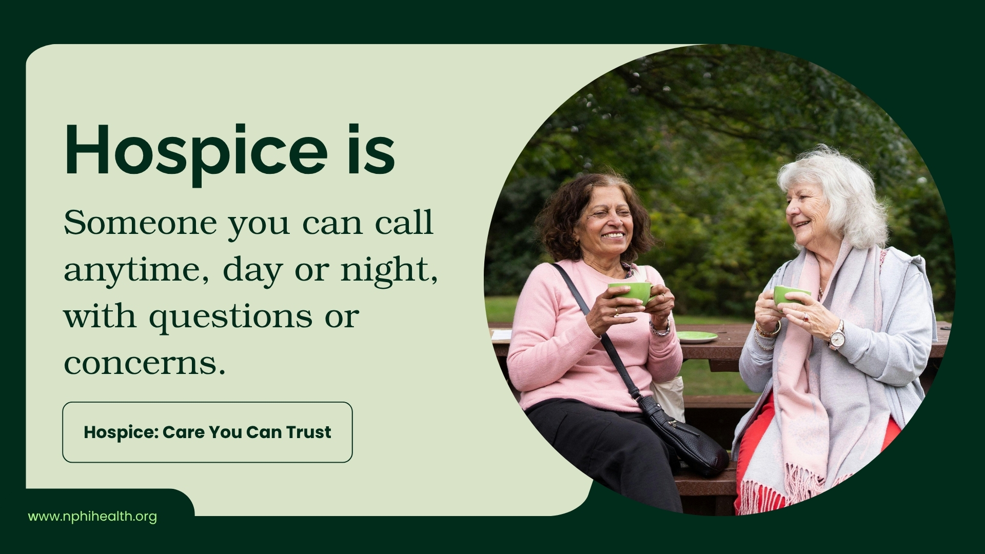  Graphic 10
Title: Hospice Is Covered  Facebook / Instagram / LinkedIn:  Cost shouldn't stand in the way of good care. Hospice is covered by Medicare, Medicaid, and most private insurance plans, so families can focus on spending time together instead of worrying about the bill.  #CareYouCanTrust #Hospice  X / BlueSky:  Hospice is covered by Medicare, Medicaid, and most private insurance plans.  #CareYouCanTrust #Hospice |   Graphic 11
Title: Hospice Support Continues After Loss  Facebook / Instagram / LinkedIn:  Hospice care doesn't end when a loved one passes away. Families receive extra support for months afterward, including counseling and check-ins, because healing takes time and no one should have to grieve alone.  #CareYouCanTrust #Hospice  X / BlueSky:  Hospice offers special support for families, even after a loved one has passed.  #CareYouCanTrust #Hospice | 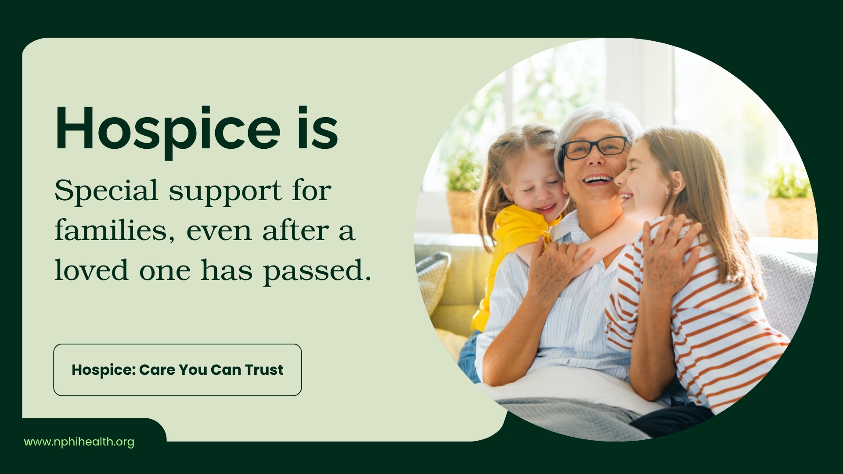  Graphic 12
Title: Hospice Guides Families Through Tough Decisions  Facebook / Instagram / LinkedIn:  Facing tough decisions about a loved one's care is hard to do alone. A hospice team walks families through those choices, answering questions and offering guidance every step of the way, so no one has to figure it out by themselves.  #CareYouCanTrust #Hospice  X / BlueSky:  Hospice offers guidance through tough decisions, so families don't have to figure it out alone.  #CareYouCanTrust #Hospice | 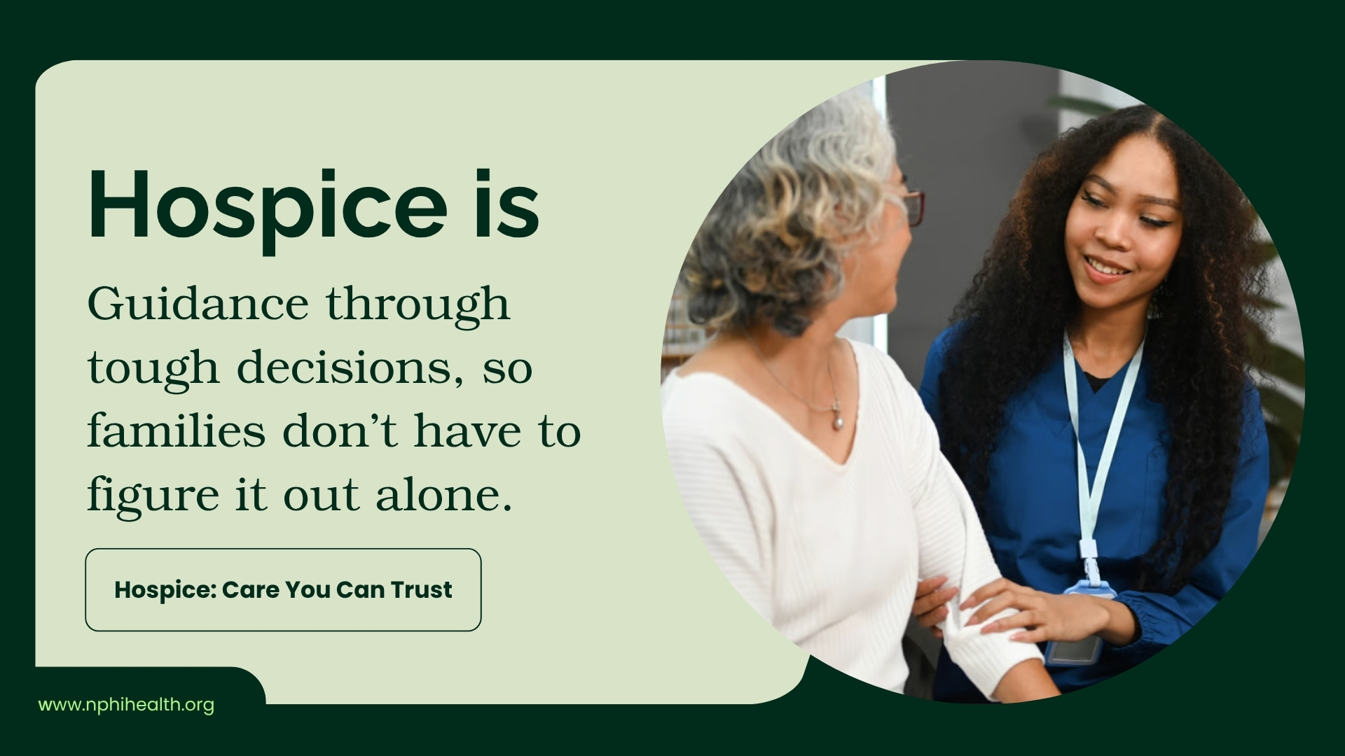  Graphic 13
Title: Hospice Supports Caregivers, Too  Facebook / Instagram / LinkedIn:  Caring for a loved one is a full-time job, and even the most devoted caregivers need rest. Hospice helps family caregivers take a break when they need it, so they can recharge and keep being there for the people they love.  #CareYouCanTrust #Hospice  X / BlueSky:  Hospice care involves a team that steps in for caregivers when they need to take a break.  #CareYouCanTrust #Hospice |   Graphic 14
Title: Hospice Brings Comfort in Unexpected Ways  Facebook / Instagram / LinkedIn:  Hospice care shows up in small moments — like a favorite meal made just right, a familiar recipe, or a hand to hold. These little touches remind patients and families that they're seen and cared for as people, not just patients.  #CareYouCanTrust #Hospice  X / BlueSky:  Hospice brings comfort in unexpected ways to help brighten people’s lives.  #CareYouCanTrust #Hospice |   Graphic 15

Additional Graphics
Graphics 16-27 are extra graphics that our team created with messages on them that you can edit. We encourage you to create your own social media language to accompany these graphics.

