EXTRA POSTS:
Hospice Sample Social Media Language

Overview
"Care You Can Trust" is a reminder that quality hospice care is built on a commitment to the people it serves. In a time where trust in hospice care has been tested, this campaign is an opportunity to set the record straight — to show the public what real hospice care looks like, and to celebrate the organizations and care teams who deliver it with integrity every single day.
This past year, hospice fraud has gotten a lot of attention in the media. That coverage has made it more important than ever to get back to basics: to clearly explain what quality hospice and palliative care actually look like.
This document gives NPHI members (and non-members can join!) the language and graphics needed to communicate clear messages throughout the month of November. Members are encouraged to also review the full Messaging Toolkit on our Campaign Hub for additional guidance and context.

Messaging Goals
- Invite public reflection, participation, and storytelling around hospice care
- Shift the narrative: hospice is about living well on your own terms. It is not about giving up.
- Educate the public about what hospice really is
- Celebrate care teams and caregivers for their compassion and share uplifting stories about patients
- Use positive and uplifting imagery and plain English that can be understood at a 6th grade reading level
- Build public trust by being honest, clear, and consistent in every message

Sample Social Posts
Sample Language | Accompanying Graphic
Title: What Hospice Care Includes  Facebook / Instagram / LinkedIn:  Hospice care involves a personal care team coming to your home [or your loved one], support for caregivers so they can rest, help with medications and equipment, and someone to call anytime, day or night.  #CareYouCanTrust #HospiceMonth  X / BlueSky:  Hospice care looks like a full care team at home, caregiver support, help with supplies, 24/7 calls, comfort-focused care, and support for families after loss.  #CareYouCanTrust #HospiceMonth | 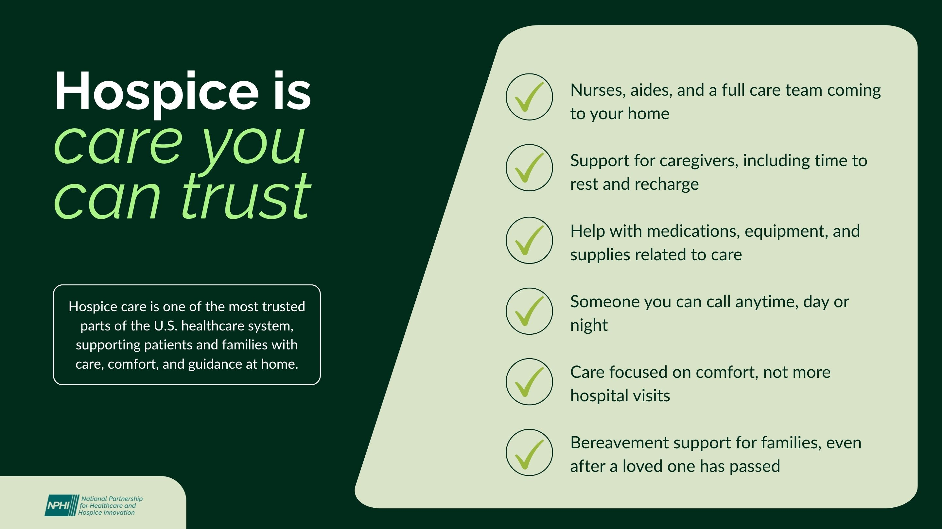  Graphic 1
Title: Who Hospice Is For  Facebook / Instagram / LinkedIn:  Hospice care is one of the most trusted parts of the U.S. healthcare system. It's for people who are very unwell and aren't expected to get better. It’s for families and caregivers who need support and guidance, and for anyone who needs a little extra care.  #CareYouCanTrust #HospiceMonth  X / BlueSky:  Hospice is for people who are very unwell, for families who need support, and for anyone who needs a little extra care.  #CareYouCanTrust #HospiceMonth | 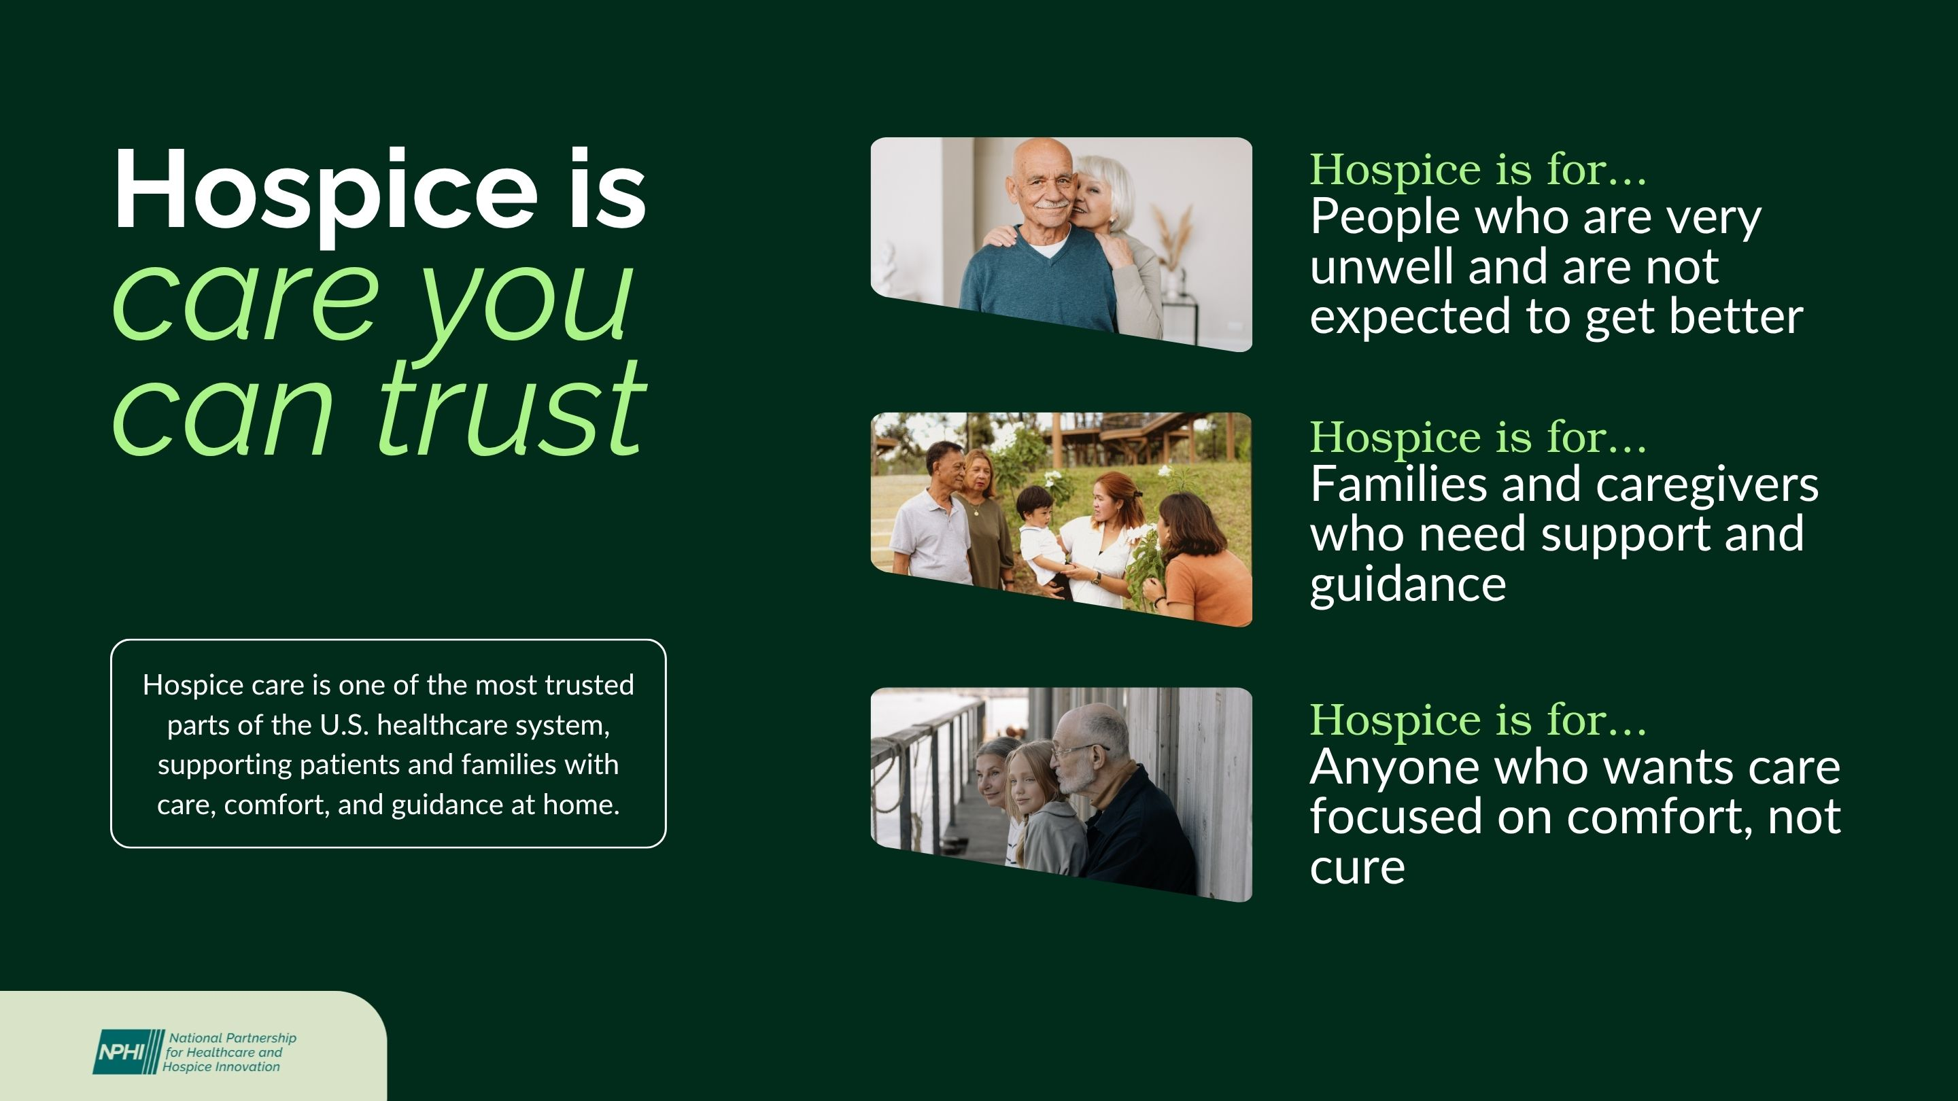  Graphic 2
Title: Signs of Quality Hospice Care  Facebook / Instagram / LinkedIn:  Not all hospice care looks the same.  Hospice care goes beyond basic medical care. It means spiritual support for every faith, special programs to honor veterans for their service, a nurse just a phone call away, day or night, and so much more.  #CareYouCanTrust #HospiceMonth  X / BlueSky:  Hospice offers spiritual care for every faith, special honors for veterans, a nurse available 24/7, and so much more. Here's what to look for.  #CareYouCanTrust #HospiceMonth | 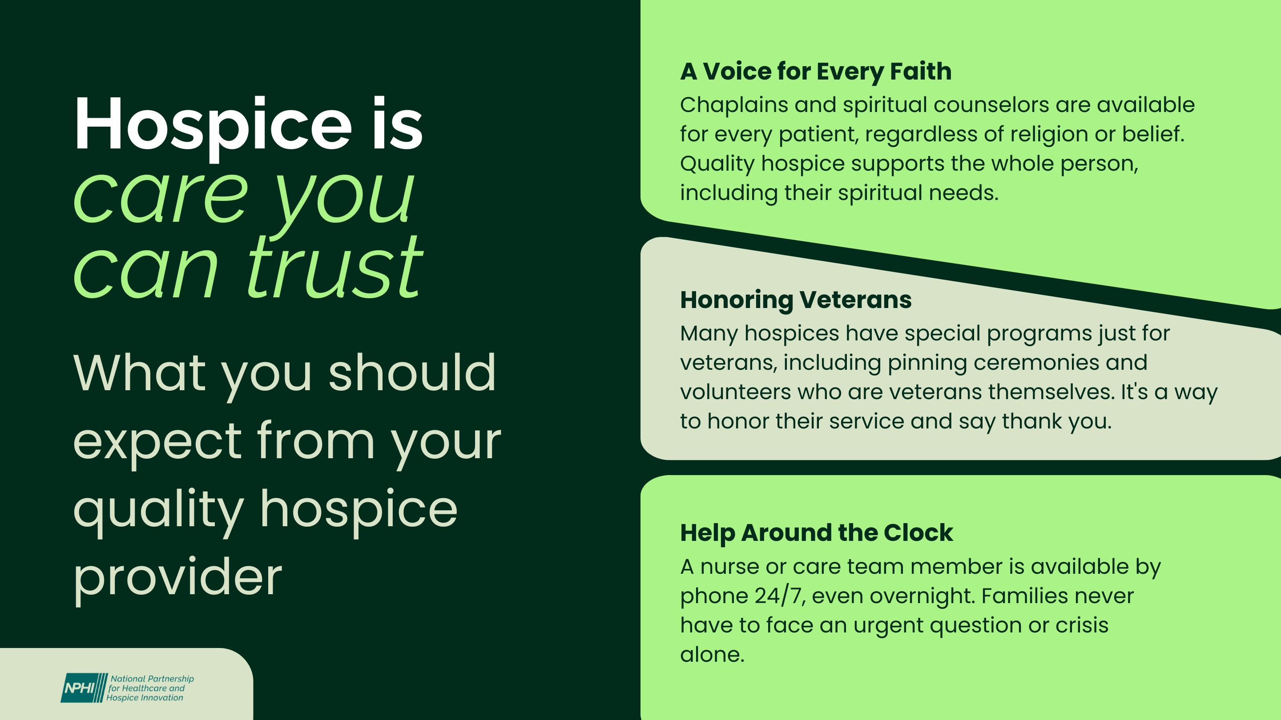  Graphic 3
Title: Hospice: What It Really Is  Facebook / Instagram / LinkedIn:  A lot of people don’t really understand what hospice care is.  Let's clear up a few common myths:  ❌ Myth: Hospice is only for someone's last few days.  ✅ Fact: Many people receive hospice care for months.  ❌ Myth: Choosing hospice means giving up your other doctors.  ✅ Fact: Your hospice team works alongside them.  ❌ Myth: Hospice is only about dying.  ✅ Fact: Hospice is about helping people live as comfortably and fully as possible.  #CareYouCanTrust #HospiceMonth  X / BlueSky:  Hospice is one of the most misunderstood types of care—but that's okay. We're here to help.  Take a look at this graphic to separate myth from fact and learn what hospice care is really about.  #CareYouCanTrust #HospiceMonth | 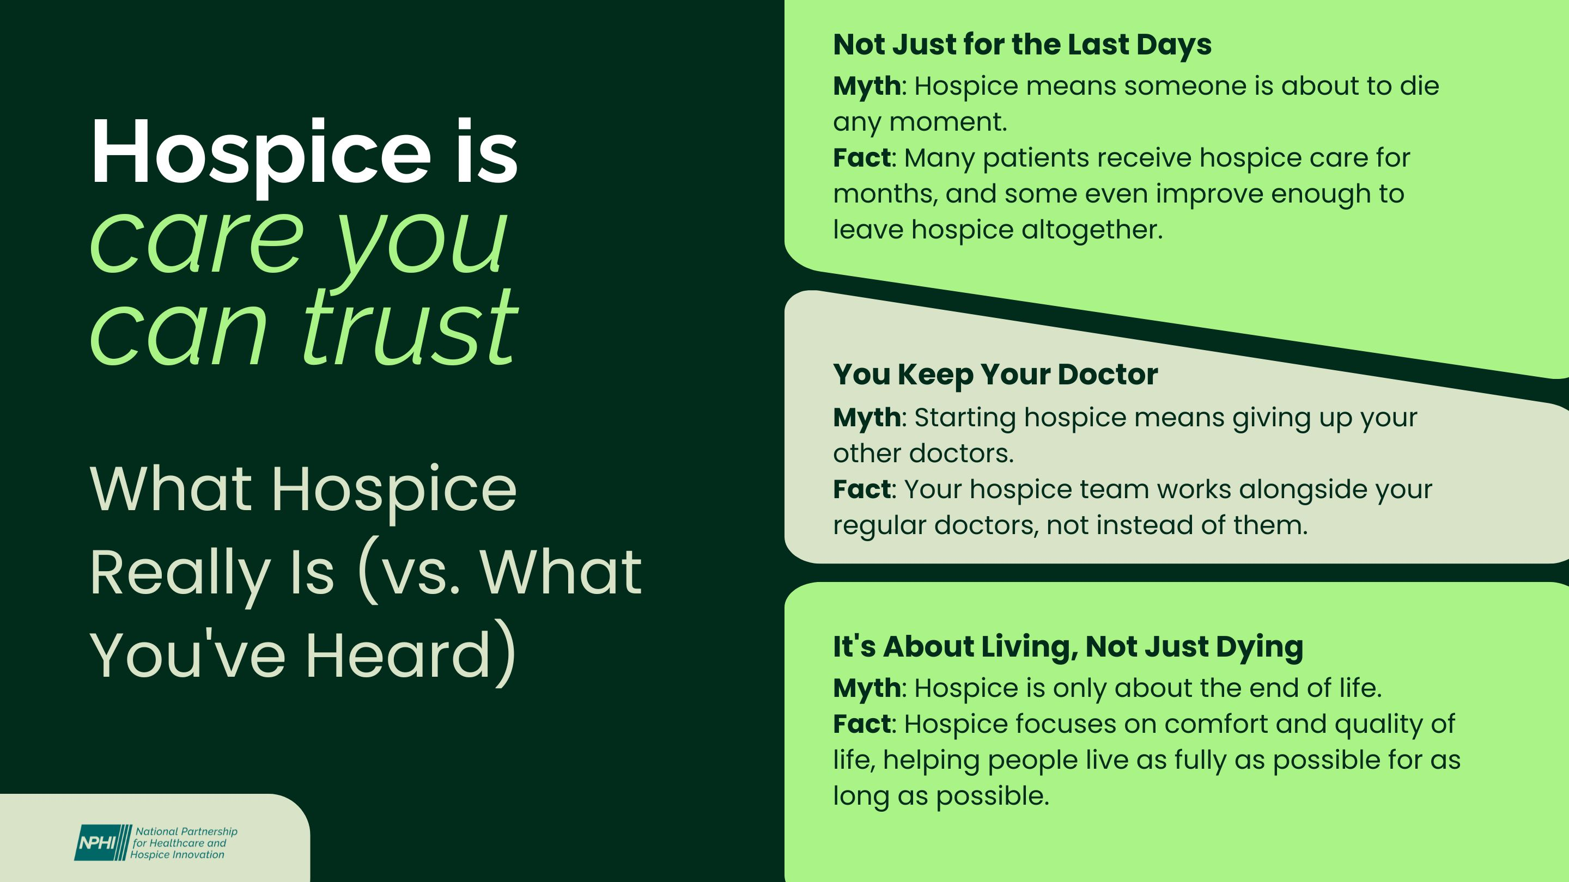  Graphic 4

